Double Data Types
# Source: AI Source: Provided by: [Data Path: Persons Table -> ID Column: 1, Name_En Column: Motasem Essam] -> From: [Chatgpt (GPT‑5 Mini)] on [12/10/2025]
A double is a data type used to store decimal numbers with higher precision than float.
It uses double-precision floating-point format, meaning it can store more accurate decimal values.

Key Characteristics
# Source: AI Source: Provided by: [Data Path: Persons Table -> ID Column: 1, Name_En Column: Motasem Essam] -> From: [Chatgpt (GPT‑5 Mini)] on [12/10/2025]
- Stores numbers with decimals
- Higher precision than float
- Typically uses 8 bytes (64 bits) of memory
- Can represent very large or very small numbers

Example Values
# Source: AI Source: Provided by: [Data Path: Persons Table -> ID Column: 1, Name_En Column: Motasem Essam] -> From: [Chatgpt (GPT‑5 Mini)] on [12/10/2025]
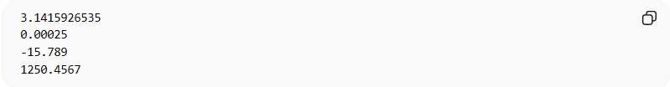
3.1415926535
0.00025
-15.789
1250.4567

Example in Programming

C / C++ / Java
# Source: AI Source: Provided by: [Data Path: Persons Table -> ID Column: 1, Name_En Column: Motasem Essam] -> From: [Chatgpt (GPT‑5 Mini)] on [12/10/2025]
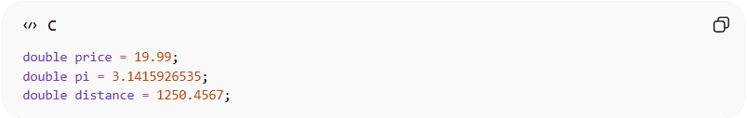
double price = 19.99;
double pi = 3.1415926535;
double distance = 1250.4567;

Python
# Source: AI Source: Provided by: [Data Path: Persons Table -> ID Column: 1, Name_En Column: Motasem Essam] -> From: [Chatgpt (GPT‑5 Mini)] on [12/10/2025]
(In Python, decimal numbers are usually stored as double-precision floats.)
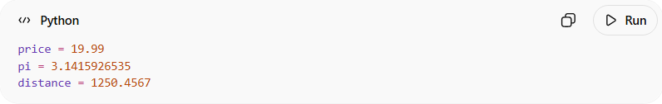
price = 19.99
pi = 3.1415926535
distance = 1250.4567

Memory and Range (Typical)
# Source: AI Source: Provided by: [Data Path: Persons Table -> ID Column: 1, Name_En Column: Motasem Essam] -> From: [Chatgpt (GPT‑5 Mini)] on [12/10/2025]
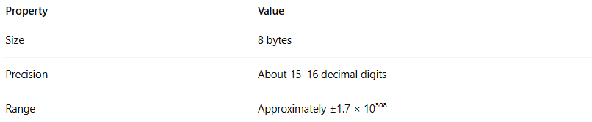
Property | Value
Size | 8 bytes
Precision | About 15–16 decimal digits
Range | Approximately ±1.7 × 10³⁰⁸

Example Calculation
# Source: AI Source: Provided by: [Data Path: Persons Table -> ID Column: 1, Name_En Column: Motasem Essam] -> From: [Chatgpt (GPT‑5 Mini)] on [12/10/2025]
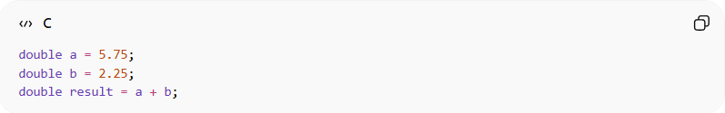
double a = 5.75;
double b = 2.25;
double result = a + b;
Result: 8.0

When to Use double
# Source: AI Source: Provided by: [Data Path: Persons Table -> ID Column: 1, Name_En Column: Motasem Essam] -> From: [Chatgpt (GPT‑5 Mini)] on [12/10/2025]
Use double when:
- Higher accuracy is required
- Working with scientific calculations
- Performing engineering or financial calculations
- Handling large or very precise numbers

Float vs Double
# Source: AI Source: Provided by: [Data Path: Persons Table -> ID Column: 1, Name_En Column: Motasem Essam] -> From: [Chatgpt (GPT‑5 Mini)] on [12/10/2025]
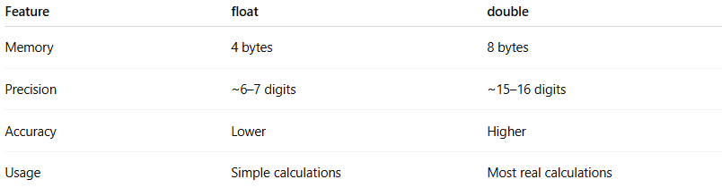
Feature | float | double
Memory | 4 bytes | 8 bytes
Precision | ~6–7 digits | ~15–16 digits
Accuracy | Lower | Higher
Usage | Simple calculations | Most real calculations

Important:
# Source: AI Source: Provided by: [Data Path: Persons Table -> ID Column: 1, Name_En Column: Motasem Essam] -> From: [Chatgpt (GPT‑5 Mini)] on [12/10/2025]
In many programs, double is preferred over float because it provides better precision.

